Our dear colleague and friend, April Dawn Strader, 47, passed away peacefully Tuesday, Oct. 3, 2017, with loving daughter Olive and dear friends in Barnes-Jewish Hospital in St. Louis. April was born April 28, 1970, in Simi Valley, California, the daughter of Michael Gary and Margaret Anne Strader. April was a talented artist in the areas of painting and photography as well as an animal enthusiast, rescuing many sick, injured, and abandoned creatures. She was a devoted mother to Olive LaRose (age 9). By her own example April encouraged Olive to be creative and tenacious. They spent many hours together traveling to and from gymnastics events as well as exploring the natural wonders of Southern Illinois. An outdoor memorial celebration was held on Saturday, Oct. 14, at Walkers Bluff Winery. Memorials may be made to the Olive LaRose Trust, P.O. Box 2101 Carbondale, IL 62902.
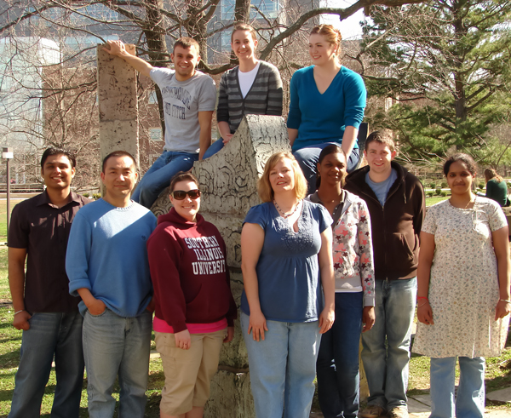
April worked at Southern Illinois University School of Medicine as an Associate Professor in the Department of Physiology. Her academic research was focused on the exploration of surgical methods of treating obesity and type II diabetes. She received her BA in Biological Sciences at the University of California Berkeley in 1992, following in the tradition of her parents who were both graduates of Berkeley. She then received an MS (1995) and PhD (2002) in Biological Sciences at University of Wisconsin Milwaukee Medical School. From 2002-2005 April was a Post-doctoral Fellow, Department of Psychiatry, University of Cincinnati, in the laboratory of Dr Randy Seeley. She then joined the faculty as Assistant Professor of Physiology, Southern Illinois University School of Medicine in 2005. She was promoted with tenure to Associate Professor in 2011. April was an outstanding teacher who owned the renal physiology curriculum and taught actively in the year 1 curriculum as a tutor and topic expert delivering resource sessions on acid-base physiology and the kidney. She taught in the Advanced Mammalian Physiology course in the Department of Physiology and was highly regarded as a teacher and mentor. She had an active laboratory group and mentored PhD, MS and undergraduate Physiology and Biomedical Engineering students. SHE was gaining an international reputation in diabetes obesity surgery and was awarded a prestigious NIH RC1 Challenge Grant (RO1), “The role of bile as a mechanism in the improvement in glucose homeostasis following bariatric surgery”
1 April Strader with her lab group at Southern Illinois University campus in Carbondale circa 2011 http://www.siumed.edu/~astrader/
April was a rising star in diabetes research using cutting edge obesity surgery as a therapeutic approach, that she helped to pioneer. Obesity surgery is the most effective treatment for morbid obesity. Remarkably, most type-II diabetic patients who undergo obesity surgery experience complete resolution of their diabetes. The intriguing aspect of the remission of diabetes is that it occurs often immediately following surgery, prior to any substantial weight loss. Her research studied the role of the small intestine and bile as contributors to the improved glucose metabolism following obesity surgery. Her landmark contribution was developing specialized surgical procedures that highlight the role of the lower intestine in glycemic control, paving the way for improved surgical treatment of obesity and metabolic disorders.
Her work lives on as her protégé Dr. Ping Zhao, Assistant Professor, Biological Sciences, North Alabama University, continues the studies, with the timely publication in August, 2017 of Ping Zhao, Donna Wendt, April Strader “Adaptation of Intestinal and Bile Acid Physiology Accompany the Metabolic Benefits Following Ileal Interposition in the Rat”, in Obesity Surgery (2017).

